1. Install R, while installing, check to create shortcut on desktop
2. Download MiKTeX and install it
3. Right click on R (x64) icon on desktop, and “run as administrator”, and run these commands:

Install.packages(“rmarkdown”)

if(!require(installr)) { install.packages("installr"); require(installr)}

install.pandoc()

When pandoc is installing, click to accept terms in license agreement.

1. Restart computer as instructed by pandoc
2. Download the pipeline files, and configure
3. When running for the first time, the program may ask to install some .sty file needed by TeX. Install the needed files.
4. Go to Windows, search for MiKTex console
   1. In updates, click check for updates

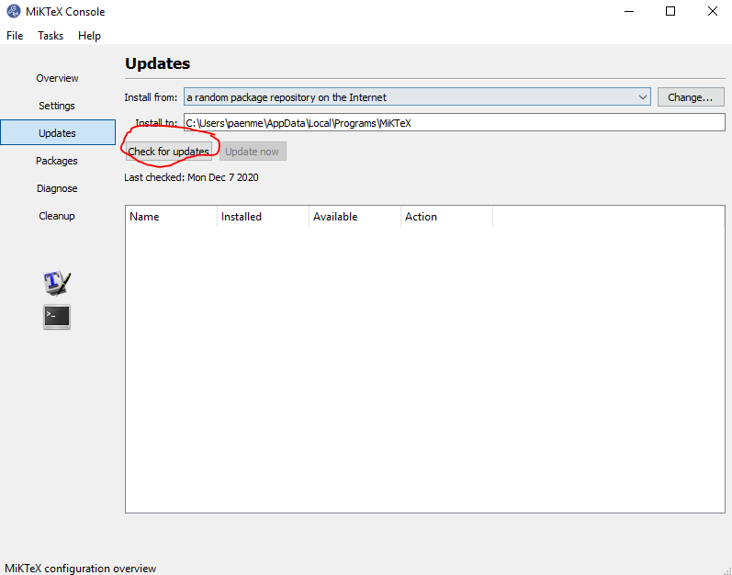

When the packages are loaded, click “update now”

* 1. In settings, check “always install missing packages on-the-fly”

